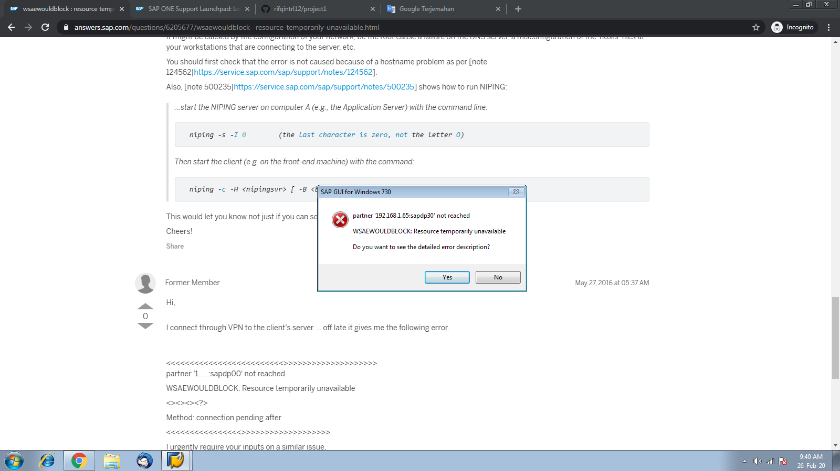

---------------------------
SAP GUI for Windows 730
---------------------------
partner '192.168.1.65:sapdp30' not reached

Time Wed Feb 26 09:35:36 2020
Component NI (network interface)
Release 730
Version 40
Module nibuf.cpp
Line 4658
Method NiBufIConnect: connection pending after 10000ms
Return Code -10
System Call connect
Error No 10035
Error Text WSAEWOULDBLOCK: Resource temporarily unavailable
Counter 1

---------------------------
OK
---------------------------

